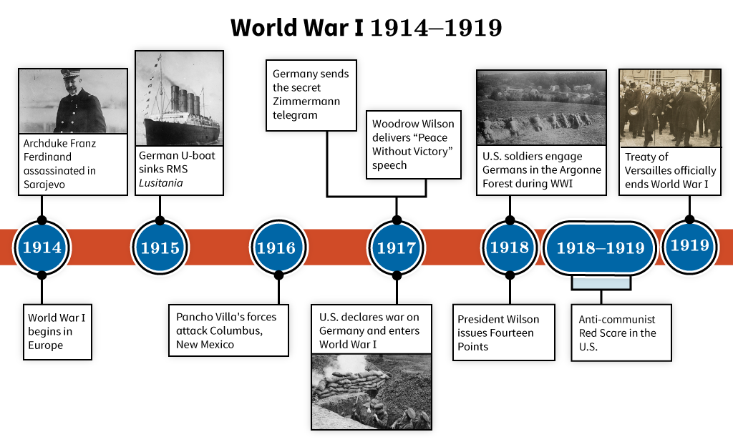

World War I

U.S. History Unit Companion
Directions
- Complete the Prepare section before you begin a unit.
- Complete the Lesson Summaries and Guided Notes section as you work through each lesson.
- Complete the Unit Review sections before you take the cumulative assessment.
NOTE: Your teacher may require that you complete and submit this unit companion.
To complete this document, you must download and save the PDF. After downloading the PDF, open the Adobe® Acrobat Reader program on your computer, select File, and then Open. Locate and open the file saved on your computer's hard drive. Fill out the PDF in Acrobat Reader and select Save. It is not recommended to fill in the form while it is open within your internet browser; this can result in the loss of all entered information.

Prepare
Throughout the World War I unit, you will explore the following Essential Questions.

Unit Essential Questions
- Was world war inevitable in 1914?
- Was it possible for the United States to maintain neutrality in World War I?
- Should the United States have entered World War I?
- Should a democratic government tolerate dissent during times of war or other crises?
- Was the Treaty of Versailles a fair and effective settlement for lasting world peace?
You will learn about the following topics in the World War I unit:
- factors leading to U.S. involvement in the war
- role of new military technology and strategy
- how Americans contributed to wartime efforts at home and abroad
- outcome of the war and negotiations for peace
- postwar challenges and changes in the United States
You will take a cumulative quiz and test over the content in this unit.

Lesson Summaries and Guided Notes
Each lesson is summarized on the following pages. Read the summary before a lesson to preview the most important information, including people, places, and events. Read the summary after a lesson to review the lesson content without rereading every word. As you complete each lesson, record information in the Guided Notes section. Some questions have been provided for you. You may also take notes on other important lesson information.

From Neutrality to War Summary
In 1914, most of the countries in Europe were at war with each other. A web of alliances between many countries meant that once one country went to war with another, others were pulled into the conflict. The United States was determined to remain neutral in a war that seemed very far away in both physical geography and American interests. But events unfolded that made it impossible for America’s president, Woodrow Wilson, to keep his vow of neutrality. This lesson explains why the war started and what drew the United States into it. You will use primary sources to learn about the shift from neutrality to war.
From Neutrality to War Guided Notes
Prior to the outbreak of the war, what were the two alliances that competed in Europe? (slide 3) | The two competing alliances in Europe were the Triple Entente and the Triple Alliance.
What caused the war to break out in Europe? (slide 3 interactive activity)
What is an example of unrestricted submarine warfare that affected the United States? (slide 4)
What were some of President Wilson’s reasons for maintaining neutrality? (slide 5)
What event finally pushed the United States to enter the war? (slide 6 podcast)

Americans in the Trenches Summary
Modern weapons of war used in World War I, such as airplanes and submarines, changed how wars would be fought in the future. Once the United States was firmly committed to war, the American Expeditionary Forces, led by General John J. Pershing, joined the other members of the Allied forces in the trenches and airfields of France and Belgium. The war brought challenges as well as opportunities to the men and women who served. Many wrote letters describing their experiences or kept journals of their daily activities. You will use primary sources to learn about what life was like for the Americans who went to war.
Americans in the Trenches Guided Notes
Why did President Woodrow Wilson send U.S. troops to Europe without putting them through extensive training? (slide 2) | The Germans were rapidly advancing toward the Allied lines on the Western Front. British and French forces asked Wilson to send American troops without extensive training because they needed reinforcements as quickly as possible.
What was a doughboy? (slide 3)
What were the technological advancements that made combat challenging and complex during World War I? (slide 4 interactive activity)
What was life in the trenches like? (slide 5 video)
Who were the Harlem Hellfighters? (slide 6)
What opportunities for minorities arose during the war? (slide 6)

The Home Front Summary
While the war raged in Europe, those on the home front in the United States rallied to support the war effort. People made sacrifices, from rationing food and supplies to leaving familiar, traditional roles behind to fill the gaps on the factory lines. People tended victory gardens, raised money, and volunteered their time. The federal government created new agencies to help these efforts succeed. Propaganda messages kept people focused on war efforts. Dissent was not allowed. This lesson provides an overview of the efforts at home that supported the efforts abroad.
The Home Front Guided Notes
What is the purpose of propaganda? (slide 2) | The purpose of propaganda is to persuade an audience to agree with the ideas expressed about a cause or to spark action for that cause.
Why was the Selective Service Act of 1917 passed? (slide 3)
What agencies were created to conserve food and fuel supplies? (slide 5)
What agency was created in order to ensure the production of sufficient military supplies? (slide 5)
Which groups experienced new job opportunities during the war? (slide 8)
What measures were taken to ensure American loyalty during the war? (slide 9)

Wilson and Peace Summary
Compared to its allies, the United States spent a short time in battle during World War I. Through a series of battles on the Western Front, American troops helped secure the Allied victory. But when peace was declared in November 1918, President Wilson’s battles did not cease—they changed. Wilson launched efforts to establish a lasting peace in Europe and worked to get Congress and the American public to support those efforts. This lesson outlines those efforts by President Wilson, including the Fourteen Points and the Treaty of Versailles.
Wilson and Peace Guided Notes
By what principle did President Wilson think nations should be governed? (slide 1) | President Wilson believed that nations should be afforded the right to determine for themselves how they would be governed. This right is called the principle of self-determination.
What causes of World War I were addressed in President Wilson’s Fourteen Points? (slide 2 video)
In what major battles did the American Expeditionary Forces take part? (slide 3)
What was the outcome of the Paris Peace Conference? (slide 5 text asset)
Which politicians opposed the Treaty of Versailles on all grounds? (slide 5 text asset)
Why did the United States never officially sign the Treaty of Versailles? (slide 7)

Aftermath of World War Summary
After the war ended, the United States continued to face difficult challenges. Just as the troops returned home, an unusually deadly flu pandemic swept the globe. African American troops who had been treated with respect in Europe came home to find racial tension. Wages remained the same, but goods rose in price, creating economic tensions. A wave of anti-communist fear caused Americans to spy on each other. Many Americans were left to wonder what, if anything, the country had gained from fighting the war.
Aftermath of World War Guided Notes
How did citizens react to the deadly flu pandemic of 1918? (slide 2) | Americans avoided public gatherings and children wore surgical masks to school. People reacted with fear and hysteria. More than 50 million people died worldwide during the pandemic.
What caused inflation to skyrocket after the war? (slide 3)
What caused an increase in racial tensions after the war? (slide 4)
How did World War I affect Prohibition and the women’s suffrage movement? (slide 5)
Why did people in the U.S. fear communism after the war? (slide 6)
Why did the United States return to isolationism after the war? (slide 7)

Unit Review – Key Words
Describe the following key words from the World War I unit. Your descriptions should be as detailed as possible. Include names, dates, and relevant facts related to each key word. Be sure to explain why each person or term is important.
Remember to download and save this PDF before writing.

From Neutrality to War
Key Word | Description
alliances | formal agreements between nations for mutual support in case of war
Archduke Franz Ferdinand
imperialism
militarism
militarization
moral diplomacy
nationalism
neutrality
preparedness campaign
RMS Lusitania
Triple Alliance
Triple Entente
unrestricted submarine warfare
Zimmermann telegram

Americans in the Trenches
Key Word | Description
American Expeditionary Forces | also referred to as AEF, the American forces in Europe during World War I
doughboys
General John J. Pershing
Harlem Hellfighters
trench warfare
U-boat
Western Front

The Home Front
Key Word | Description
Committee on Public Information | government agency that created propaganda to convince people to support World War I with money and volunteer efforts
conscientious objector
conscription
draft
Espionage Act of 1917
Food Administration
Fuel Administration
Herbert Hoover
Liberty Loan Act
mass media
propaganda
ration
Schenck v. United States
Sedition Act of 1918
Selective Service Act of 1917
War Industries Board

Wilson and Peace
Key Word | Description
Alvin C. York | American army sergeant who received numerous military honors for his service in France during World War I
armistice
Battle of Argonne Forest
Battle of Cantigny
Fourteen Points
Henry Cabot Lodge
Hundred Days’ Offensive
interventionist
Irreconcilables
isolationist
League of Nations
Meuse-Argonne Offensive
Paris Peace Conference
Reservationists
Second Battle of the Marne
self-determination
Treaty of Versailles

Aftermath of World War
Key Word | Description
A. Mitchell Palmer | United States Attorney General from 1919–1921
Chicago Race Riot of 1919
Eighteenth Amendment
flu pandemic of 1918
inflation
interventionism
isolationism
Nineteenth Amendment
Palmer Raids
Prohibition
Red Scare
Red Summer
suffrage
Tulsa Race Massacre of 1921

Unit Review – Key Questions
Before the unit assessment, answer the following key questions. Each question contains a tip to help you locate the material in the course. You may want to add your own note in the first column about the location of the information. Write the answers in your own words, and test your memory of each answer by covering the answer column while quizzing yourself. Remember that some content may be presented in a multimedia presentation, graphic, or other resource. Refer to the transcripts or text versions for written versions of that content.
Key Question / Location | Answer in Your Own Words
Why did the United States wish to remain neutral at the outbreak of the war? (From Neutrality to War) | Most Americans considered the war in Europe to be of no national interest to the United States. The alliances between and among European nations did not concern the American public. During the presidential election of 1916, President Wilson promised to keep the United States out of war, and most Americans agreed with that. The prospect of war was costly, both in material and lives, and many Americans did not see a compelling reason to go to war.
What roles did militarism, alliances, imperialism, and nationalism play in the outbreak of war in Europe? (From Neutrality to War)
What was the impact of new military technology on World War I? (Americans in the Trenches)
How were the experiences of different groups of Americans at war in Europe similar and different? (Americans in the Trenches)
How did people on the home front support the war effort? (The Home Front)
What measures did the United States government institute during World War I? (The Home Front)
How did the United States alter the outcome of World War I? (Wilson and Peace)
What was the purpose of Wilson’s Fourteen Points? (Wilson and Peace)
How did the United States respond to the different changes and challenges it faced after World War I? (Aftermath of World War)
How did the outcome of World War I shape the international role of the United States? (Aftermath of World War)

