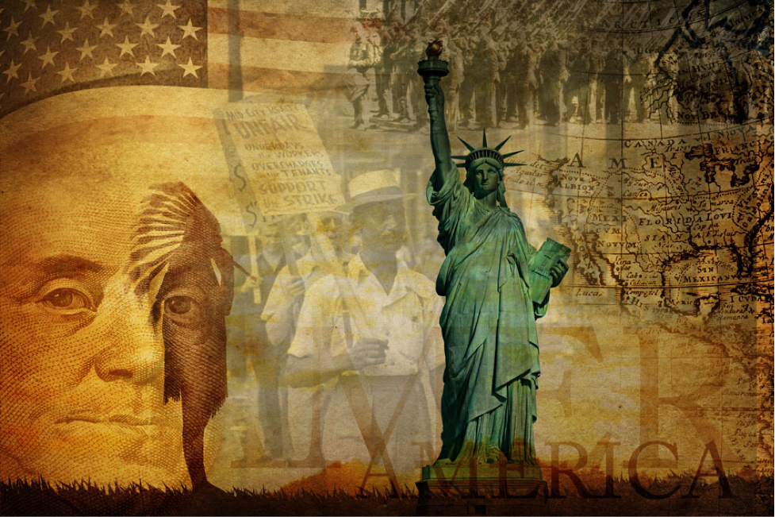

The Cold War

U.S. History Unit Companion
Directions
- Complete the Prepare section before you begin a unit.
- Complete the Lesson Summaries and Guided Notes section as you work through each lesson.
- Complete the Unit Review sections before you take the cumulative assessment.
NOTE: Your teacher may require that you complete and submit this unit companion.
To complete this document, you must download and save the PDF. After downloading the PDF, open the Adobe® Acrobat Reader program on your computer, select File, and then Open. Locate and open the file saved on your computer's hard drive. Fill out the PDF in Acrobat Reader and select Save. It is not recommended to fill in the form while it is open within your internet browser; this can result in the loss of all entered information.

Prepare
Throughout The Cold War unit, you will explore the following Essential Questions.

Unit Essential Questions
- What economic and social changes took place in the United States after World War II?
- What were the causes and effects of The Cold War?
- What world events led to the Korean War?
- What results did the fear of communism have on foreign policies and everyday life?
- How did family structure and cultural norms change after World War II?
- How did marginalized groups begin to find their voice in the 1950s?
You will learn about the following topics in The Cold War unit:
- the efforts made to educate war veterans and reintroduce them to society
- the inequality in economic prosperity during the post-war era
- the foreign policies of the post-war presidents
- China’s adoption of communism and its role in the Korean War
- the long-term impacts of the Korean War
- the escalation of the arms race and space race
- the widespread fear of communism in the United States
- changes in family structure and the role of women
- popular culture of the 1950s
- early events that led to the Civil Rights Movement

You will take a cumulative quiz and test over the content in this unit.

Lesson Summaries and Guided Notes
Each lesson is summarized on the following pages. Read the summary before a lesson to preview the most important information, including people, places, and events. Read the summary after a lesson to review the lesson content without rereading every word. As you complete each lesson, record information in the Guided Notes section. Some questions have been provided for you. You may also take notes on other important lesson information.

The U.S. After World War Summary
Following the war, American soldiers hoped for a quick return to civilian life. President Truman carried out a rapid effort of demobilization, or removal of troops from active duty. Despite the desire to return home, many soldiers struggled to readjust to civilian life. Many experienced psychological problems as a result of the horrors they experienced during the war.
However, the postwar era was a time of economic prosperity. American consumerism increased, and new social programs such as the G.I. Bill of Rights helped give white Americans economic security. African Americans and Hispanic Americans were often denied these financial benefits and therefore could not achieve the middle-class lifestyle of white Americans. After returning from internment camps, Japanese Americans struggled to rebuild their lives amid tremendous racial prejudice.
The postwar era brought demographic change as well. As soldiers returned from the war, there was an increase in marriages and births. More families purchased homes in suburban communities. The Second Great Migration of African Americans moving from the South to northern and western states in search of job opportunities contributed dramatically to demographic changes as did the movement of people of all races to the Sunbelt in search of warmer weather and better jobs.
The move away from cities to the suburbs meant a greater need for cars. Not only did the automobile industry grow, but so did drive-in and drive-through stores, restaurants, and movie theaters. The National Interstate and Defense Highways Act of 1956 provided funding for the construction of new roads and highways for commuters from the suburbs to the cities. This increased funding for highway transportation had a negative impact on urban communities, who saw reduced funds for public transportation.
The U.S. After World War Guided Notes
What was demobilization?  (slide 1) | Demobilization referred to a reduction of the number of combat-ready troops. After World War II, American soldiers were eager to return home, so President Truman carried out a very rapid demobilization effort.
What were some concerns that World War II soldiers had about returning to civilian life?
(slide 1)
How did the economy boom after the war?
(slide 2)
How did the Serviceman’s Readjustment Act, or G.I. Bill, lead to a more educated and highly-skilled workforce than ever before?
(slide 2)
Why were more white Americans able to afford a middle-class lifestyle than people of other races and cultures?
(slide 3)
What challenges did Japanese Americans face after the war?
(slide 3)
What demographic changes occurred after the war?
(slide 4)
What was the Second Great Migration?
(slide 4)
What effects did suburbanization have on the automobile industry? (slide 5)
What were the results of the National Interstate and Defense Highways Act of 1956?
(slide 5)

The Cold War Begins Summary
Although the United States and the Soviet Union were allies during World War II, their opposing goals in the postwar era turned them into enemies. U.S. President Harry Truman wanted to expand capitalism and the United States’ influence around the world. Soviet leader Joseph Stalin wanted to expand Soviet control and communism to other countries. Soon the two countries were locked in a lengthy Cold War. It was called a Cold War because neither country fired a weapon at the other, but instead both countries built up weapons in an attempt to intimidate each other.
Both countries were eager to gain control in other countries, many of which were unstable after the war. The United States and Soviet Union exerted their control over other countries by forming alliances, as well as providing financial and military aid.
The Cold War Begins Guided Notes
Why did the alliance between the United States and the Soviet Union collapse after World War II?  (slide 1) | The United States and the Soviet Union were allies during World War II. However, after the war, it became clear that the two countries had very different visions for the future. Joseph Stalin of the USSR wanted to expand Soviet influence by spreading the Communist philosophy to other countries. Harry Truman of the United States wanted to prevent the spread of Communism and expand America’s influence by promoting free-marking economies in other countries. Relations between the U.S. and the Soviet Union were already strained as the war came to a close, and after the war the two countries went from allies to enemies.
Watch the video entitled “Origins of the Cold War.” According to the video, what was Stalin’s greatest concern? What concerns did Truman have?
(slide 1 video)
Why did the United States have to shift from its traditional policy of isolation to one of accepting foreign alliances?
(slide 2)
Why did the United States and the Soviet Union emerge as superpowers after World War II?
(slide 2)
What was the purpose of the Truman Doctrine?

(slide 3)
Why did the United States adopt the strategy of containment?
(slide 3)
What was the emphasis of Eisenhower’s New Look strategy? (slide 3)
Why did the United States offer economic aid to European countries under the Marshall Plan?
(slide 4)
What was Stalin’s motivation for the Berlin Blockade?
(slide 5)
What were NATO and the Warsaw Pact?
(slide 5)
Why were the Middle East and Latin America important battlegrounds in the Cold War?
(slide 6)

China and the Korean War Summary
Political and economic conditions in the 1920s strengthened the Communist Party in China. By 1949, the Communist Party had officially taken control of China. In Asia, the Soviet Union had taken control of North Korea, while the separate country of South Korea remained a democracy. When Communist forces from North Korea invaded South Korea in 1950 in an attempt to unify the peninsula under communist control, the United States sent troops to fight on South Korea’s side to stop the spread of communism.
U.S. troops under General Douglas MacArthur quickly defeated North Korean troops in South Korea, and the North Korean’ retreated. MacArthur believed the United States would not be completely victorious, however, until communist North Korea was destroyed. A series of conflicts emerged between the United States and North Korea, which China supported with troops. MacArthur wanted to deploy nuclear weapons against China, but President Truman believed the use of nuclear weapons would lead to a larger war in Asia. MacArthur criticized Truman publicly and was eventually fired for insubordination.
The Korean War raged on until 1953. In the end, both sides agreed to a border between North and South Korea close to the original 38th parallel. A demilitarized zone (DMZ) was established between the two countries, and political prisoners were allowed to choose which side of the line they would live. Today, North Korea remains a communist country, while South Korea is still a democracy.
China and the Korean War Guided Notes
Why was the Chinese Communist Party eventually victorious over the Nationalist Party in 1949?  (slide 1) | Years of corruption had weakened the Nationalist Party. The Chinese Communist Party was boosted by grassroots efforts from struggling peasants who looked to Communism to improve conditions in China. The Communist Party also had a stockpile of Japanese weapons. On October 1, 1949, the Chinese Communists officially declared victory over the Nationalist Party.
What event marked the beginning of the Korean War?
(slide 2)
Where else in Asia did the United States become involved in to stop the spread of communism?
(slide 2)
What actions did U.S. forces take to drive North Korean forces back across the 38th parallel?
(slide 3)
How did General Douglas MacArthur’s views differ from those of President Truman?
(slide 3)
What were the results of the armistice agreement of July 1953?
(slide 4)
What differences exist in North Korea and South Korea, even to this day?
(slide 4)

The Cold War Intensifies Summary
As the Soviet Union expanded its influence and nuclear arsenal, Americans became more afraid of communist infiltration. Known as the Second Red Scare, this fear led to paranoia that many Americans were acting in cooperation with Soviet spies. As a result, the FBI led by J. Edgar Hoover surveilled government workers suspected of subversive activities. In the age of McCarthyism, famous people and celebrities were tried by the House Un-American Activities Committee, and many were blacklisted when the committee determined they had communist sympathies.
Throughout the 1950s, the United States and Soviet Union competed to build up their weapons arsenals including hydrogen bombs and long-range missiles . As it became clear that a Soviet nuclear attack was possible, the United States invested more money and effort into civil defense and created the Federal Civil Defense Administration to help ordinary citizens prepare their towns and families for a nuclear attack. Civil defense efforts included building of bomb shelters and conducting nuclear attack drills in schools. The government also produced literature trying to ease Americans’ minds about the destructiveness of nuclear fallout.
The arms race soon extended into a race to be the first nation to launch satellites and people into space. When the Soviet Union launched Sputnik, the first artificial satellite, into space, the United States created NASA to compete with the Soviets in the space race.
The Cold War Intensifies Guided Notes
Which events contributed to the phenomenon known as the Second Red Scare?  (slide 1) | The Soviet Union exploded its first atomic bomb. The communists seized control of China. Americans began to worry about the spread of communism and communist infiltration. This fear is known as the Second Red Scare. The first Red Scare had been in 1919.
What were some of the consequences of the widespread fear of Communist infiltration?
(slide 2)
What was the result of the Rosenberg trial?
(slide 2)
Describe the activities of the House Un-American Activities Committee.
(slide 3)
What was McCarthyism?
(slide 3)
What actions were taken by the Americans and the Soviets in the arms race?
(slide 4)
How did the arms race become a space race?
(slide 4)
What actions did the government take to help families prepare for a nuclear attack?
(slide 5)
What was “mutually assured destruction”?
(slide 6)

Cultural Transformations in the 1950s Summary
Societal expectations of the ideal American family changed after the war. Women who had worked at war jobs were encouraged to quit their jobs and focus on their families instead. The ideal American family was seen to be one with a working father, a stay-at-home mother, several children, a house in the suburbs, and at least one car.
Consumerism was encouraged during the postwar period as well. After years of doing without during the Great Depression and World War II, Americans now had disposable income to spend. The advertising industry found a new market in teenagers, who had money to spend, and encouraged them to buy a variety of products geared toward them.
Televisions were an example of a consumer product that increased tremendously in popularity during the 1950s. Television shows spanned a wide variety of genres and often promoted American values of individualism and family. Shows were not racially diverse, however—most portrayed white families, and the few exception portrayed African Americans negatively.
Not everyone bought into the idea of the idealized middle-class life, however. The Beat movement started with a group of writers in New York who rejected traditional popular culture. Even everyday teens sought to rebel against the confines of conventional society by listening to rock and roll music, which many parents disliked.
Cultural Transformations in the 1950s Guided Notes
How did society’s expectations about the roles of women change after World War II?  (slide 1) | During the war, many women worked outside the home in factories that produced supplies necessary for the war effort. After the war, women were encouraged to quit working so that returning soldiers could have their jobs. There was pressure on women to focus on taking care of their homes and families instead of working outside the home.
Why was there a rise in consumerism after the war?
(slide 2)
How did the Baby Boomers influence the advertising industry? (slide 2)
What was the television industry’s depiction of the ideal American family?
(slide 3)
What products developed as a result of the popularity of television?
(slide 3)
How was television in the 1950s racially biased?
(slide 3)
What was the Beat movement and how did it develop?
(slide 5)
Why was rock and roll popular with teenagers?
(slide 6)
Why did many adults dislike rock and roll. (Slide 6)

The Civil Rights Movement Begins Summary
During the postwar period, efforts toward racial equality formed the seeds of the Civil Rights Movement. President Truman issued an executive order for the military to integrate troops. Schools were required to integrate when the Supreme Court declared school segregation unconstitutional. However, white pushback against school integration made desegregation of schools so challenging that federal troops were called in to protect African American school children.
Americans were beginning to see the horror of racism. The case of Emmett Till, a black teenager murdered by whites in Mississippi, shocked both black and white Americans. This case inspired people to take action against racism.
One important action took place when a black woman named Rosa Parks was arrested for refusing to give her seat to a white man on a Montgomery, Alabama bus in 1955. This incident led to the Montgomery Bus Boycott.
Legislation, most famously The Civil Rights Act of 1957, helped protect civil rights for all Americans. Another challenge to segregation came from the success of black athletes in sports.
Other ethnic groups also faced discrimination. Asian Americans dealt with prejudice resulting from the war and the Red Scare. Mexican Americans turned to courts to earn the right to attend white schools. Native Americans fought in court after the government took their land.
The Civil Rights Movement Begins Guided Notes
Why did President Truman issue Executive Order 9981?  (slide 1) | After the war, civil rights leaders urged the government to pass legislation that would ensure racial integration of the military. However, senators from the South threatened to block any such legislation. President Truman bypassed Congress by issuing Executive Order 9981, which called for equal treatment for all members of the armed forces. All branches of the military cooperated except the Army, which didn’t become racially integrated until it needed more troops for the Korean War.
What was the outcome of the Brown v. Board of Education decision?
(slide 2)
How did landmark court cases protect the civil rights of Mexican Americans?
(slide 6)
What rights were protected under the Civil Rights Act of 1957?
(slide 2)
What challenges did the Little Rock Nine face while attending a previously all-white school?
(slide 3)
What was the Montgomery Bus Boycott?
(slide 4)
What law was passed as a result of the Montgomery Bus Boycott? (slide 4)
How did the athletic achievements of Jackie Robinson and Alice Coachman help African Americans break the color barrier in sports?
(slide 5)
What challenges did Asian Americans face in the 1950s?
(slide 6)
How did government policies negatively impact Native Americans in the 1950s?
(slide 6)
What was the main goal of AIM? (slide 6)

Unit Review – Key Words
Describe the following key words from The Cold War unit. Your descriptions should be as detailed as possible. Include names, dates, and relevant facts related to each key word. Be sure to explain why each person or term is important.
Remember to download and save this PDF before writing.

The U.S. After World War
Key Word | Description
baby boomers | Baby Boomers refers to the generation of people born between 1946 and 1964. After the war, soldiers were eager to come home and start families, and the large number of babies born in the postwar period is referred to as a baby boom.
demobilization
fair deal
G.I. Bill of Rights
middle class
National Interstate and Defense Highways Act (1956)
Social Security Disability Insurance of 1956
suburbanization
Taft-Hartley Act of 1947
Truman’s labor policy
Twenty-second Amendment
welfare

The Cold War Begins
Key Word | Description
atomic bomb | An atomic bomb is a highly powerful weapon that generates massive explosive power through nuclear fission.
Berlin Blockade
brinkmanship
containment
Domino Theory
flexible response
Iron Curtain
Marshall Plan
NATO
Truman Doctrine
United Nations
Warsaw Pact

China and the Korean War
Key Word | Description
38th Parallel | The 38th parallel is a line of latitude that forms the official border between North Korea and South Korea.
Korean War
Douglas MacArthur
Mao Zedong

The Cold War Intensifies
Key Word | Description
Alger Hiss case | In this case, former state department official Alger Hiss was convicted of perjury for lying under oath about his connection to the Communist Party.
American Communist Party
Arms Race
blacklisting
bomb shelters
Whittaker Chambers
Federal Employees Loyalty Program
J. Edgar Hoover
House Un-American Activities Committee
Lavender Scare
McCarthyism
Mutually assured destruction
Julius and Ethel Rosenberg
Second Red Scare
Sputnik

Cultural Transformations in the 1950s
Key Word | Description
Beat movement | The Beat movement was a literary movement that achieved prominence in the 1950s. The writers in the movement were nonconformists who rejected popular American culture.
consumerism
rock and roll

The Civil Rights Movement Begins
Key Word | Description
Brown v. Board of Education | Brown v. Board of Education was a landmark civil rights case in the United States Supreme Court. The Court declared that state-enforced segregation of public schools was unconstitutional.
Civil Rights Act of 1957
Executive Order 9981
Hernandez v. Texas
Little Rock (1957)
Montgomery Bus Boycott
Rosa Parks
Jackie Robinson

Unit Review – Key Questions
Before the unit assessment, answer the following key questions. Each question contains a tip to help you locate the material in the course. You may want to add your own note about the location of the information. Write the answers in your own words, and test your memory of each answer by covering the answer column while quizzing yourself. Remember that some content may be presented in a multimedia presentation, graphic, or other resource. Refer to the transcripts or text versions for written versions of that content.
Key Question / Location | Answer in your own words
What economic and social trends occurred after World War II?  (The U.S. After World War) | Congress passed various laws that affected Americans, including the G.I. Bill of Rights and Truman's Fair Deal program. The government also put money into the defense industry and into universities conducting research, which helped the economy tremendously. The construction and automobile industries provided new jobs, and many people moved into new homes in the suburbs. With extra money to spend, people bought appliances, carpeting, furniture, and home decorations, which further strengthened the economy. Unemployment was low, and wages for members of both the working and middle classes were high.
What were the reasons for the economic disparity between white Americans’ postwar lifestyles and the lifestyles of other races?
(The U.S. After World War)
Why did the United States and the Soviet Union go from being allies during World War II to enemies in the post-war period?
(The Cold War Begins)
How did the Cold War between the United States and the Soviet Union spread to other countries around the world?
(The Cold War Begins)
How did the Communist party gain strongholds in Asia after World War II?
(China and the Korean War)
Why did the United States get involved in the Korean War?
(China and the Korean War)
What were some of the results of the fear of Communist infiltration during the Second Red Scare?
(The Cold War Intensifies)
Describe the arms race and the space race.
(The Cold War Intensifies)
What societal norms were Americans pressured to conform to during the 1950s?
(Cultural Transformations in the 1950s)
In what ways did people rebel against conformity during the 1950s?
(Cultural Transformations in the 1950s)
What important events occurred during the early Civil Rights movement? (The Civil Rights Movement Begins)
How did different ethnic groups fight for equal rights during the 1950s?
(The Civil Rights Movement Begins)

